Workshop Bodenburg
Water
Headed by:
Prof. Dr. Heinrich Kramer
Participants:
Thomas Roth
Jens-Peter Reichert
Melanie Deeken
Nicole Oelkers
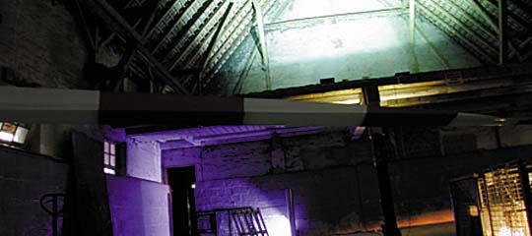
The group headed by Heinrich Kramer addressed the overall theme of the workshop. Their task was to illuminate the ground floor of the bulls' stable, which contained various objects - comparable to a museum or display setting - and to produce a lighting concept for the empty barn, where the lighting equipment for the workshop was stored in crates. This latter space contained certain architectural elements, such as the wooden structure of the roof, the former hay loft, the arrangement of windows, and the entrance and exit zones.
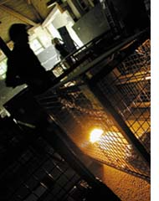
The definition of these spatial elements formed the basis for the conceptual phase. Extensive wall surfaces in an adjacent, empty space allowed the group to experiment with light as an exclusive means for creating atmosphere.
The real work comprised locating the existing and impressive architectural elements and designing lighting to accentuate them or make them more easily legible. Having developed a concept, the group found they had to amend some of their ideas in practice. Specific objects in the space that caught the group's eye were illuminated dramatically to produce almost artistic light and shadow effects: a mirror, an old broom, the crates the luminaires were in, or palettes that had been left there. The result was therefore a mixture of 'straight' architectural lighting, designed to allow the visitors to see, read and enjoy the spaces after dark, and event lighting, de-signed to address the visitors' emotions.
The knowledge that the people coming to view the installations on the final night would be mainly inhabitants of Bodenburg had a considerable influence on the realisation of the lighting. With time the group developed an effective and clearly defined lighting installation. Effects of contrast were designed to be striking enough so as not to be commonplace. It was therefore not surprising that functional lighting took second place to lighting effects with more emotional appeal.
The ground floor of the bulls' stable with the various objects that were to be lit was complemented by some interesting, but discreet effects. The outer curtain walls were backlit, the pillars accentuated. In general, the visitors to the final event were more attracted to the coloured lighting installations than to the sobre illumination of the objects in the bulls' stable. The learning effect was therefore all the more significant for the workshop participants. When they become practising lighting designers, they must be aware of how to design effective, functional lighting.

